**Deep Skilling Week 6 Assignment**

1. **ReactJS-HOL**

**Code:**

import React from 'react';

function App() {

return (

<div>

<h1>Welcome to the first session of React</h1>

</div>

);

}

export default App;

**OUTPUT:**

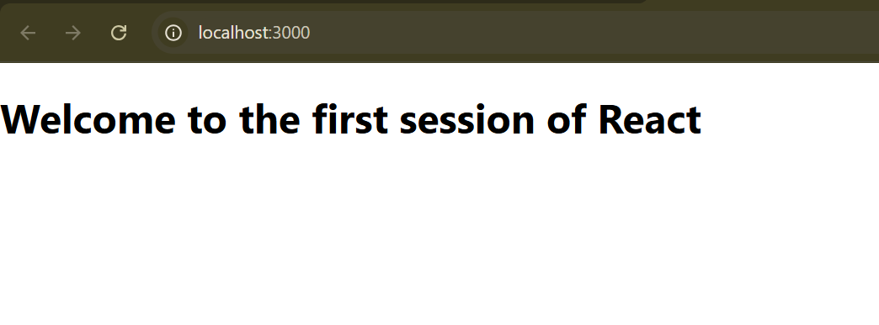

1. **ReactJS-HOL**

**Code:**

**Home.js**

import React from 'react';

function Home() {

return (

<div>

<h2>Welcome to the Home page of Student Management Portal</h2>

</div>

);

}

export default Home;

**About.js**

import React from 'react';

function About() {

return (

<div>

<h2>Welcome to the About page of the Student Management Portal</h2>

</div>

);

}

export default About;

**Contact.js**

import React from 'react';

function Contact() {

return (

<div>

<h2>Welcome to the Contact page of the Student Management Portal</h2>

</div>

);

}

export default Contact;

**App.js**

import React from 'react';

import Home from './Components/Home';

import About from './Components/About';

import Contact from './Components/Contact';

function App() {

return (

<div className="App">

<Home />

<About />

<Contact />

</div>

);

}

export default App;

**OUTPUT:**

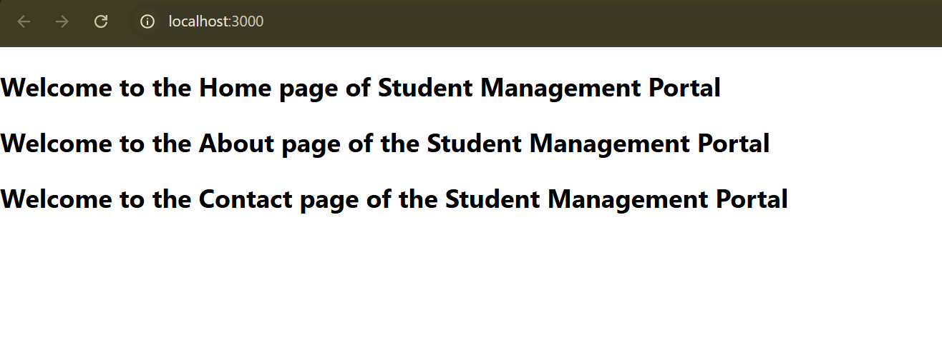

1. **ReactJS-HOL**

**Code:**

**CalculateStore.js**

import React from 'react';

import '../Stylesheets/mystyle.css';

function CalculateScore(props) {

const { name, school, total, goal } = props;

const average = total / goal;

return (

<div className="score-card">

<h2>Student Score Summary</h2>

<p><strong>Name:</strong> {name}</p>

<p><strong>School:</strong> {school}</p>

<p><strong>Total Marks:</strong> {total}</p>

<p><strong>Average Score:</strong> {average.toFixed(2)}</p>

</div>

);

}

export default CalculateScore;

**mystyle.css**

.score-card {

background-color: #f0f8ff;

border: 2px solid #007acc;

padding: 20px;

margin: 30px auto;

width: 400px;

border-radius: 10px;

font-family: 'Arial', sans-serif;

box-shadow: 0 4px 8px rgba(0,0,0,0.1);

}

.score-card h2 {

color: #007acc;

margin-bottom: 15px;

}

.score-card p {

font-size: 16px;

line-height: 1.6;

}

**App.js**

import React from 'react';

import './App.css';

import CalculateScore from './Components/CalculateScore';

function App() {

return (

<div className="App">

<CalculateScore name="Harsh Kumar" school="Woodbine Modern School" total={450} goal={5} />

</div>

);

}

export default App;

**OUTPUT:**

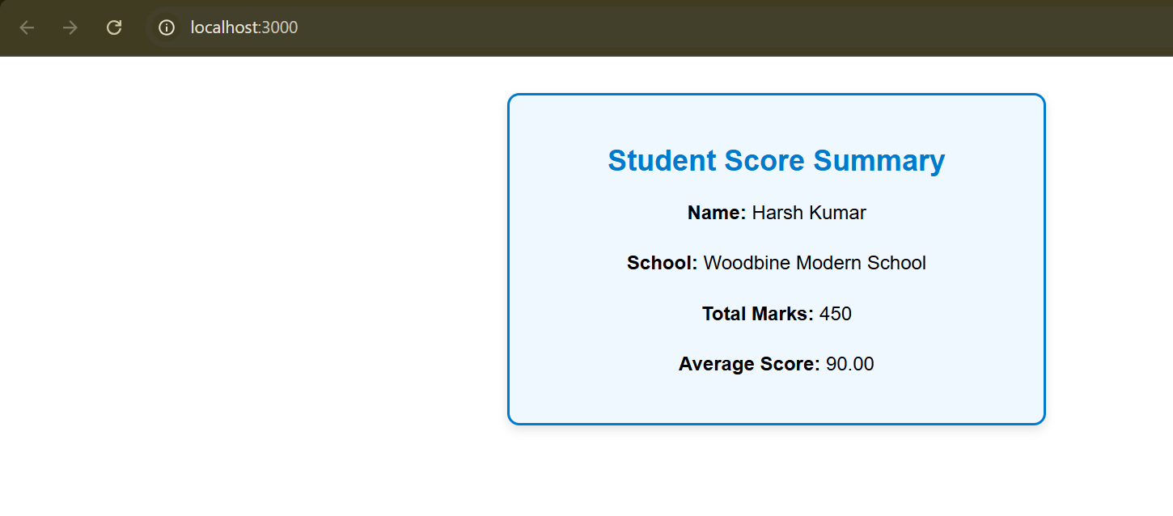

1. **ReactJS-HOL**

**Code:**

**Post.js**

import React from 'react';

class Post extends React.Component {

render() {

return (

<div style={{ marginBottom: '20px' }}>

<h2>{this.props.title}</h2>

<p>{this.props.body}</p>

</div>

);

}

}

export default Post;

**Posts.js**

import React, { Component } from 'react';

import Post from './Post';

class Posts extends Component {

constructor(props) {

super(props);

this.state = {

posts: [],

error: null

};

}

loadPosts() {

fetch('https://jsonplaceholder.typicode.com/posts')

.then(res => res.json())

.then(data => {

this.setState({ posts: data });

})

.catch(error => {

this.setState({ error });

});

}

componentDidMount() {

this.loadPosts();

}

componentDidCatch(error, info) {

alert("An error occurred: " + error);

}

render() {

return (

<div>

<h1>Blog Posts</h1>

{this.state.posts.map(post => (

<Post key={post.id} title={post.title} body={post.body} />

))}

</div>

);

}

}

export default Posts;

**App.js**

import React from 'react';

import Posts from './Posts';

function App() {

return (

<div className="App">

<Posts />

</div>

);

}

export default App;

**OUTPUT:**

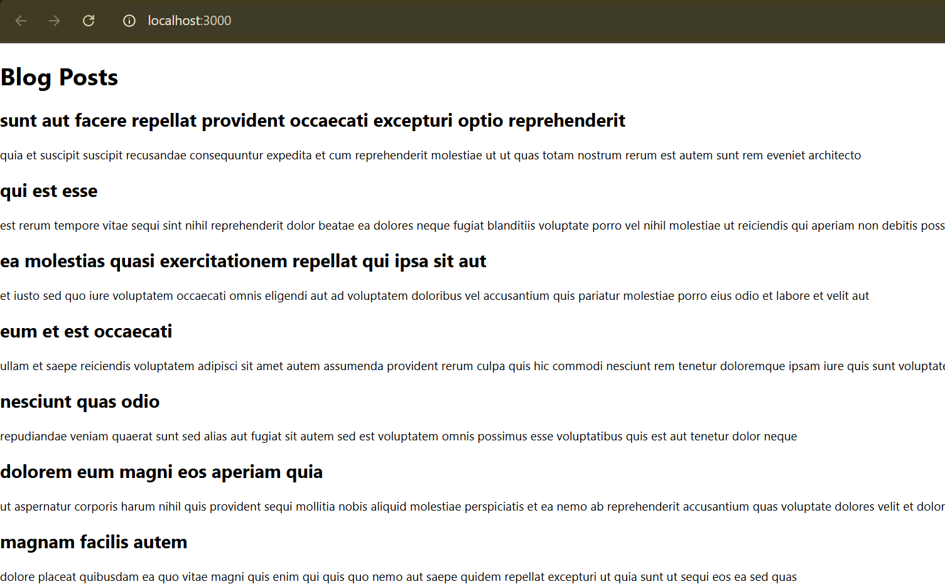

1. **ReactJS-HOL**

**Code:**

**CohortDetails.module.css**

.box {

width: 300px;

display: inline-block;

margin: 10px;

padding: 10px 20px;

border: 1px solid black;

border-radius: 10px;

vertical-align: top;

}

dt {

font-weight: 500;

}

.ongoing {

color: green;

}

.other {

color: blue;

}

**CohortDetails.js**

import React from 'react';

import styles from './CohortDetails.module.css';

const CohortDetails = () => {

const cohorts = [

{

id: 'INTADMDF10',

track: '.NET FSD',

startDate: '22-Feb-2022',

status: 'Scheduled',

coach: 'Aathma',

trainer: 'Jojo Jose',

},

{

id: 'ADM21JF014',

track: 'Java FSD',

startDate: '10-Sep-2021',

status: 'Ongoing',

coach: 'Apoorv',

trainer: 'Elisa Smith',

},

{

id: 'CDBJF21025',

track: 'Java FSD',

startDate: '24-Dec-2021',

status: 'Ongoing',

coach: 'Aathma',

trainer: 'John Doe',

},

{

id: 'INTADMJF12',

track: 'Java FSD',

startDate: '22-Feb-2022',

status: 'Scheduled',

coach: 'Ibrahim',

trainer: 'To Be Assigned',

},

{

id: 'CDE22JF011',

track: 'Java FSD',

startDate: '24-Dec-2021',

status: 'Ongoing',

coach: 'Apoorv',

trainer: 'Emma Swan',

},

{

id: 'INTADMDF09',

track: 'Dataware Housing',

startDate: '22-Feb-2022',

status: 'Scheduled',

coach: 'Aathma',

trainer: 'Babjee Rao',

},

{

id: 'ADM22DF001',

track: '.NET FSD',

startDate: '10-Sep-2021',

status: 'Ongoing',

coach: 'Ibrahim',

trainer: 'Marie Curie',

},

];

return (

<div>

<h2>Cohorts Details</h2>

{cohorts.map((cohort, index) => (

<div key={index} className={styles.box}>

<h3 className={cohort.status === 'Ongoing' ? styles.ongoing : styles.other}>

{cohort.id} - {cohort.track}

</h3>

<dl>

<dt>Started On</dt>

<dd>{cohort.startDate}</dd>

<dt>Current Status</dt>

<dd>{cohort.status}</dd>

<dt>Coach</dt>

<dd>{cohort.coach}</dd>

<dt>Trainer</dt>

<dd>{cohort.trainer}</dd>

</dl>

</div>

))}

</div>

);

};

export default CohortDetails;

**App.js**

import React from 'react';

import CohortDetails from './CohortDetails';

function App() {

return (

<div className="App">

<CohortDetails />

</div>

);

}

export default App;

**OUTPUT:**

